RT99 Test Firmware Primer
The RT99 is divided into three functional sections (files) and support files; interface.c, port.c and tcxxxx.c. These sections are divided logically to facilitate testing the part without altering the functionality of the firmware. The interface.c file contains functionality regarding the actual interface between the microprocessor and the RT99. The port.c is the implementation of the 16550 functionality including interrupt servicing, polled transfers, initializing and closing the serial port. The tcxxxx.c section is generally where the test engineer writes the test case and simulates conditions to prove functionality. There are situations that require unusual behavior, in these cases portions of port.c or interface.c can be copied to the tcxxxx.c file and altered to achieve the desired results.

Beginning a Test Case
Under the directory .\maxim-ic\Maxim UART\My Code\ create a tcxxxx directory and copy the .dep, .ewp, .ewd, .eww and tcxxxx.c files from an existing test case direct that has a similar functionality to that desired or the files from the TCTEMPLATE directory. Where that annotation “xxxx” is used, replace it with your test case number.
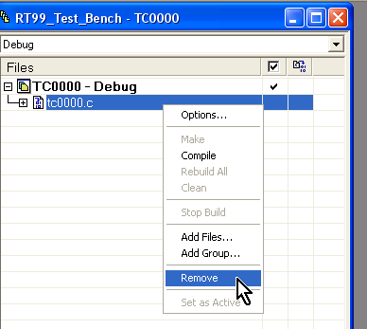
In IAR Embedded Workbench IDE environment select Project->Add Existing Project…, navigate to your tcxxxx directory and select the tcxxxx.ewp. Once your project is added to the workspace, right click on the existing .c file and remove it from the project. Right click on the project name and select “Add Files…” and add your tcxxxx.c file to the project. You are now ready to double click on the tcxxxx.c file and begin modifying your test case.

The tcXXXX.c File
This file is where the test engineer will do most of the test tasks. If copied from TCTEMPLATE.c which is shown below is a good starting point for most test cases.
A comment block is provided at the top of the file. This is followed by the #define statements which select interrupt driven or polled transfers, allows the engineer to designate which interrupts are active and choose between SPI and i²c interfaces. Then are the #include statements for the collateral files.
Before main() is an area designated to declare global variables. With the small size of most tests, it is a good idea to make most variables global. They retain their values and can be traced easier than local variables during the debug process. In the top of the main() block is an area designated to declare local variables.
Next is the section that instantiates the serial port object and initializes the RT99. The only portions necessary to edit are the arguments in the port_set() function (e.g., port_set( port, 38400L, 'N', 8, 1, NO_FIFO, FCR_RX_TRIG_1B );). Here the engineer will set the baud rate, parity and stop bit settings as well as enabling the FIFO and setting the RX FIFO trigger level.
In the “Your Code Here” section is where the engineer uses either the low level rreg() and wreg() to read and write values directly to the registers or the port_putc() and port_getc() functions to create polled or interrupt driven transfers. These functions will be discussed further in the interface.c and port.c sections.
It is a good idea to finish the test with a period of delay (e.g., testDELAY(14000);) to allow the test to finish before the firmware exits. If the test is an endless loop this will not be necessary.
Finally, is the housekeeping section where the port_close() function releases the memory used by the test case and generally sets everything back to pre-test conditions.
It is important to be aware of conditions and occurrences in the port_set() and port_close() functions to know what state the RT99 is in before and after the actual test procedure.
// File........: TCxxxx.c
// Authors.....: Your Name Here
// Description.:
//
// Conditions:
// IFACE: SPI or I2C
// BAUD: bps
// WORD: 8, N, 1
// FIFO: Yes or No
// INTS: Yes or No
//
// Date........: Today
//
// The proper interface can be found in interface.c

#ifndef TCXXXX_C
#define TCXXXX_C

// Interrupt or not? - define only one.
#define INT_DRIVEN
//#define POLLED

#define ACTIVE_INTERRUPTS IER_LINE_STATUS | IER_MODEM_STATUS | IER_RX_DATA | IER_THRE

// Which interface? - define only one.
#define IFACE_SPI
//#define IFACE_I2C

#include <stdio.h>
#include <stdlib.h>
#include <intrinsics.h> // MAXQ2000 specific stuff
#include <iomaxq200x.h> // MAXQ2000 specific stuff
#include "RT99reg.h" // RT99 Registers and bits
#include "interface.c" // SPI/I2C Implementation
#include "port.c" // RS232/16550 Implementation
///// Declare Global Variables Here ////////////////

///////////////////////////////////////////////////////////////////
main()
{
///// Declare Local Variables Here /////////////////

//////////////////////////////////////////////////////////////////
PORT *port;
port = port_open( COM1_UART );
// Check to see if port is valid
if ( port == NULL )
{
puts( "Failed to open the port!\n" );
exit( 1 );
}
port_set( port, 38400L, 'N', 8, 1, NO_FIFO, FCR_RX_TRIG_1B );
///// Your Code Here //////////////////////////////

////////////////////////////////////////////////////////////
port_close( port );
return( 0 );
} // End of main(void)

#endif

The port.c File
This file provides the 16550 functionality and consists of three sections: generic, INT_DRIVEN and POLLED.
The generic section of the port.c provides the port_open(), port_set() and port_close() functions.
The port_open() function allocates microprocessor memory initiates a ring buffer, initiates the microprocessor interface and conducts a power-on-reset of the RT99.
The port_set() function disables the interrupts, configures the FIFO and sets the baud rate and data characteristics in the RT99. If INT_DRIVEN is defined in the tcxxxx.c file, this function will configure and enable the microprocessor and RT99 interrupts. Only the interrupts defined in ACTIVE_INTERRUPTS will be activated.
NOTE: Even if the THRE interrupt is defined, it will not be enabled until the port_putc() function is called and there is data in the ring buffer waiting to be transmitted.
The port_close() function disables the microprocessor and RT99 interrupts, conducts a manual reset on the RT99 and releases the memory back to the microprocessor.
The INT_DRIVEN section consists of two functions (port_putc(), port_getc()) and the interrupt service routine.
The port_putc() function places data into the ring buffer and enables the THRE interrupt.
The port_getc() function returns the next character from the ring buffer or -1.
The interrupt service routine provides very simplistic servicing of the interrupts.
IIR_RECEIVE – reads a character from the RBR register and stores it in the ring buffer (unless full).
IIR_TRANSMIT – if there is a character in the ring buffer, it writes it to the THR. If there is no character it disable the THRE interrupt.
IIR_MODEM_STATUS – reads the MSR and stores the register value into a global variable.
IIR_LINE_STATUS – uses a simple switch statement to print which of the line status errors was received.
IIR_CHAR_TIMEOUT – simply reads the RBR register.
When more complex behavior is required from the ISR, it is best to paste it into the tcxxxx.c file and customize it for the specific test.

The interface.c File
This file contains interface specific functions which change functionality by the #define of either IFACE_SPI or IFACE_I2C in the tcxxxx.c. Currently the i2c implementation is non-functional.
The only functions of value to the test engineer are the wreg() and rreg(). These functions use the defined interface to read and write directly from and to the RT99 registers.
The comment section for each interface in the interface.c file contains a pin connection description for connecting the RT99 to the microprocessor for that particular interface.

The Collateral Files
The files, interface.c, interface.h, port.c, port.h and RT99reg.h are stored in the “.\Program Files\IAR Systems\Embedded Workbench 3.2\MAXQ\inc” directory. The RT99reg file contains defined constants to facilitate the writing of test procedures and make the test cases easier to read.

Running an Existing Test Case
First, make sure that the RT99 is connected for the proper interface as described in the interface.c file and the IO pin voltage on the microprocessor is set to a compatible level. Currently the test cases are configured to debug on Com2 and the asynchronous traffic to the RT99 is sent on Com1. The serial cables should be connected respectively.
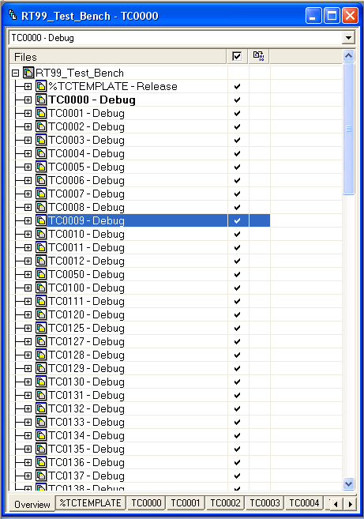
Once the devices are connected properly, enter the IAR Embedded Workbench select “File->Open Workspace…” then navigate to .\maxim-ic\Maxim UART\My Code and open the RT99_Test_Bench.eww. The engineer should see the window illustrated here.
The active project (test) is highlighted in bold. In order to run a test it must be active. To make a test active the tab can be selected or the test can be right clicked upon and “Set as Active” can be selected. Each test can be expanded and edited as needed.
NOTE: The collateral files (e.g., interface.c and port.c) are used by most tests and editing these files affects nearly every test. Use extreme caution.
Once the desired test is found and made active, the engineer should open the tcxxxx.c file and read the comment for special instructions. Most tests require the external monitor of pins with a logic analyzer, the stimulation of pins with a pattern generator or some other input. Connect the logic analyzer and pattern generator to the pins of interest and set trigger.
In the IAR IDE, click on the “Debug” button. If an error similar to the one pictured is received, the cause is likely the microprocessor communication. Check the serial cabling, re-connect the JTAG connector and restart the IAR IDE and try again.
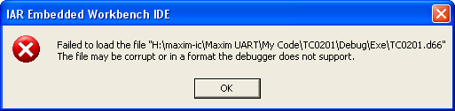
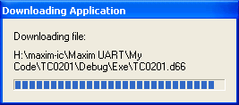
This is what you want to see. This means that your firmware is being downloaded to the microprocessor and prepared to run in debug.
The firmware may be run independent of the debug function after this download has completed. When the RESET button on the microprocessor board is released, the firmware will run. This is a quick way to repeatedly run a test without waiting for the software delay.
